Digital Invoices project Setup:

Step1: create the project using spring initializr (<https://start.spring.io/>).

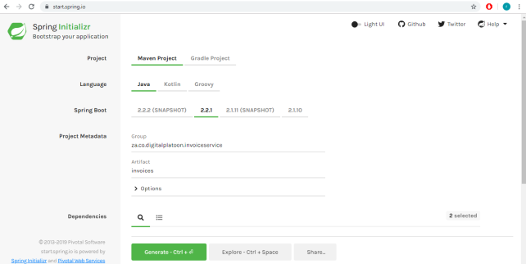

Step2: import the project in the STS IDE

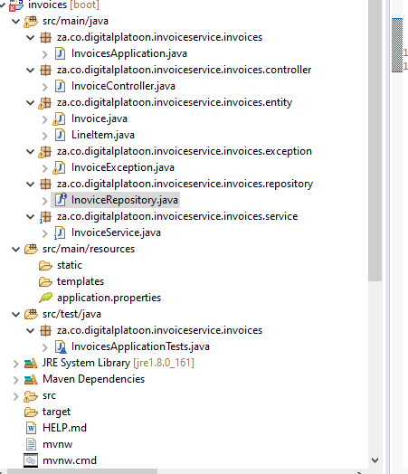

Step3:Add the invoices RestServices==

<http://localhost:8012/invoices>

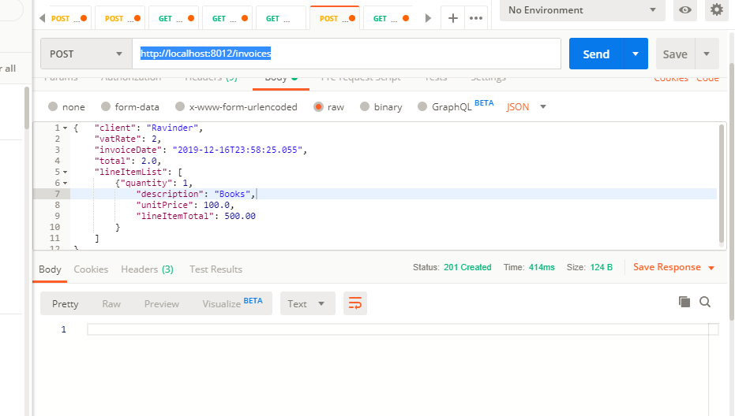

Step4: check the h2 memory DB:

<http://localhost:8012/h2-console>

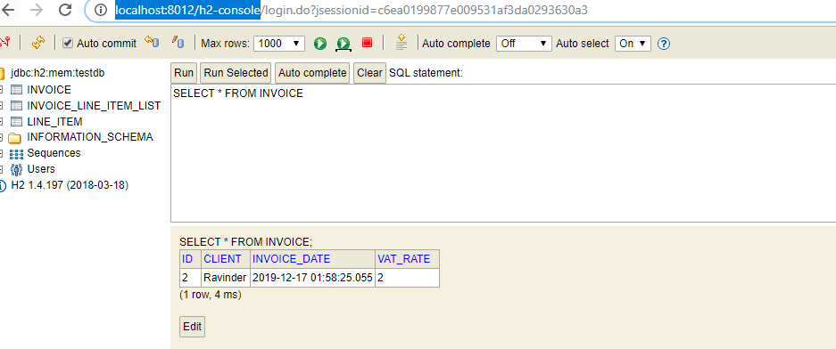

Step5: please check remaining restservices